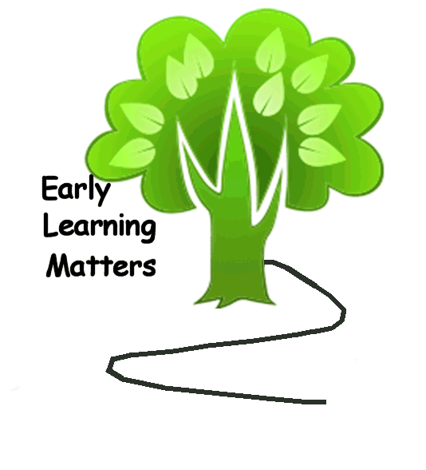  - Delicious family dinner (cooked by someone else)  - Book bag for every child (first visit each school year)  - New books every time you come  - Fun activities for you and your child  We could not have done this alone! We are very grateful to the Dennis and Phyllis Washington Foundation and Polson School District for their funding and encouragement and for the support of our community partners! |  |  | ELM- Early Learning Matters  About Us  The mission of our Early Learning Matters (ELM) project is to partner with parents and the community to prepare children from birth to age five to succeed in school.  Contact Us  Phone: 406-883-6333  Web: http://gateway.polson.k12.mt.us/  ELM- Early Learning Matters  Cherry Valley Elementary  Polson, MT 59860 |  |  | ELM- Early Learning Matters  - Polson School District

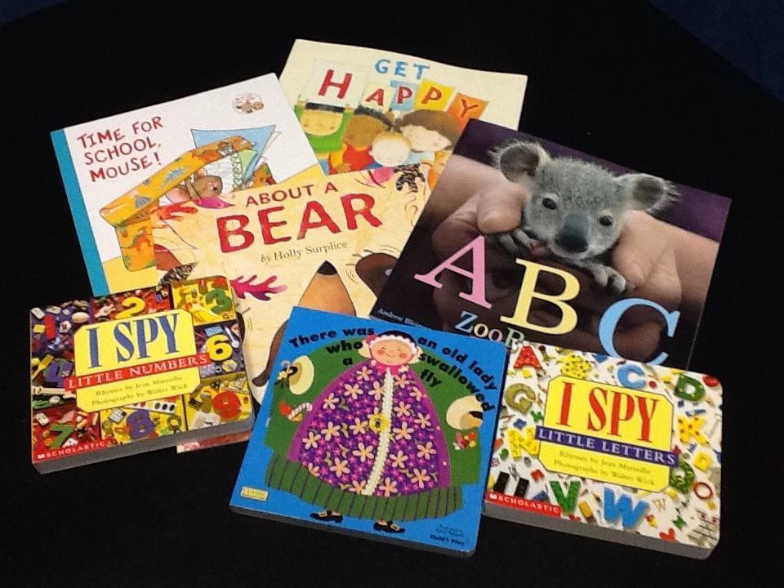  Early Learning Matters  Because parents are their children's first, best teachers  The Polson School District has long maintained that parents are their children’s first, best teachers. The goal of our Early Learning Matters (ELM) project is to empower parents to create a language-rich environment at home and make learning fun and effective for their young children starting at birth.  We do this by providing parents with hands-on interactive fun shops in which we demonstrate age-appropriate activities and effective techniques for parent-child interaction, as well as giving parents information about child development. Certified teachers lead the fun shops in which each child receives age-appropriate children’s books, educational toys, and ideas for activities to do. |  |  | “ELM gave me some great ideas to help get my kids ready for kindergarten. We also got a great dinner and I didn’t have to do dishes. What a great deal.” Katrina  A Fun Evening for families with children from 0 to 5  First Tuesday of every month  (November – May)  Cherry Valley Elementary 5:00 p.m. to 7:00 p.m.  Dinner provided  Activities and ideas are for parents and children to help with school readiness.  Come and enjoy new friends, your children, and go home with ideas and supplies to use at home.  Please call Bonnie @ 883-6333 ext. or Trude’ @ 883-6229 Ext.  . |  |  | 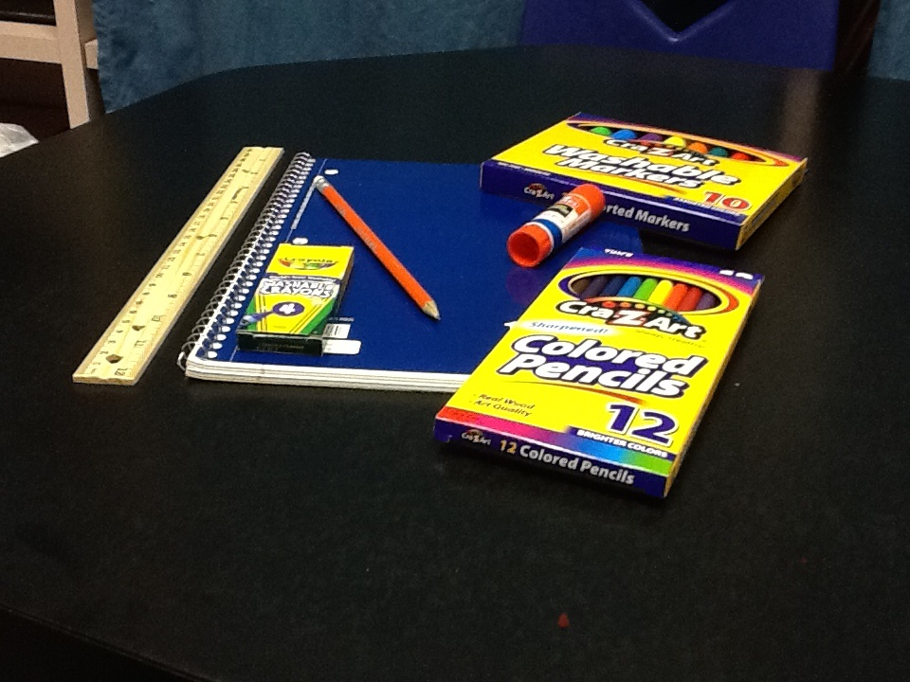  Schedule  5:00-5:45 Dinner and clean-up  5:45 -6:40 Children activities and Parent forum  6:40- 7:00 Parent and Child activities  “Children need the freedom and time to play. Play is not a luxury. Play is a necessity. ~Kay Redfield Jamison

